From the 1996 Standards of Practice
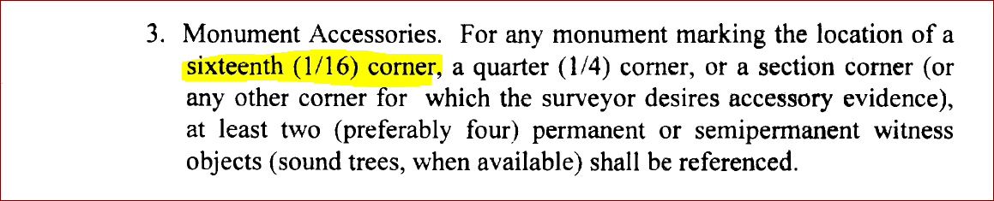
From the 2006 Standards of Practice


From the 2009 Standards of Practice
